Project Initialization and Planning Phase

Date | 20 March 2026
Team ID | SWTID-2026-4885
Project Name | Credit Card Approval System
Maximum Marks | 3 Marks

Define Problem Statements (Customer Problem Statement):

I want to apply for a credit card, but I am not sure whether I am eligible. The approval process takes time, and I do not know the reasons if my application is rejected. I also do not know which factors, such as my income, employment status, or credit history, affect the approval decision. This uncertainty makes it difficult for me to improve my chances of getting approved. I want a quick, accurate, and transparent decision so that I can plan my finances with confidence and avoid unnecessary delays or repeated applications.

Example:
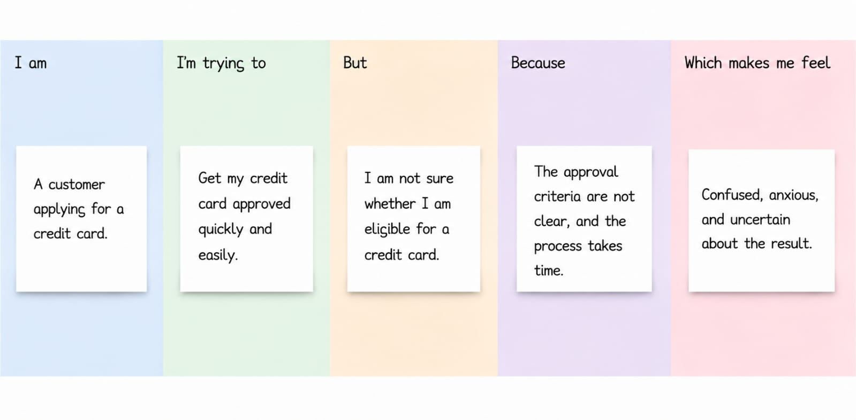

Problem  Statement  (PS) | I am (Customer) | I’m trying  to | But | Because | Which makes me feel
PS-1 | I am applying for a Credit Card | Get my credit card approved quickly and easily | I am not sure whether I am eligible for applying a credit card | The arrival criteria are not clear, and process takes time or it may due to my credit score | Confused, anxious, and uncertain about the result

